Online Medicine Shopping in PHP

Hello Friends. In this Online Medicine Shopping in PHP project’ tutorial,

To provide computerized data storage facility. We can search easily any record. The new system requires less time for completion of any work. All the stock of medicine is update automatically in the new system. The system is user friendly and anyone having computer knowledge can handle it easily. Suitability for computerized data entry. Maintaining stock, Supplier information, Customer information & bill information are easy.

#### STEP 1:

Download Code and copy to root directory of localhost.

STEP 2:

Create database with name vinod_medicine.

#### STEP 3:

Select created database and import data from vinod_medicine*.sql* file. This file located inside *sql* folder inside your downloaded folder.

Admin

#### STEP 1:

Now run *index.php* file from localhost.

E.g. http://localhost/phptutorial/OMSW/Admin/index.php By visiting *login.php* you can see the below page. 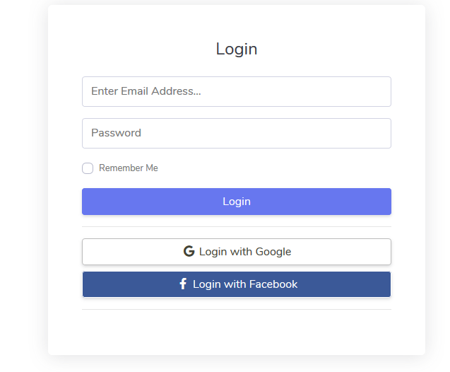

#### STEP 2:

Login with Email : *admin@gmail.com* | Password : *admin.*

STEP 3:

After login you can see the dashboard.

On this page you can see different options:

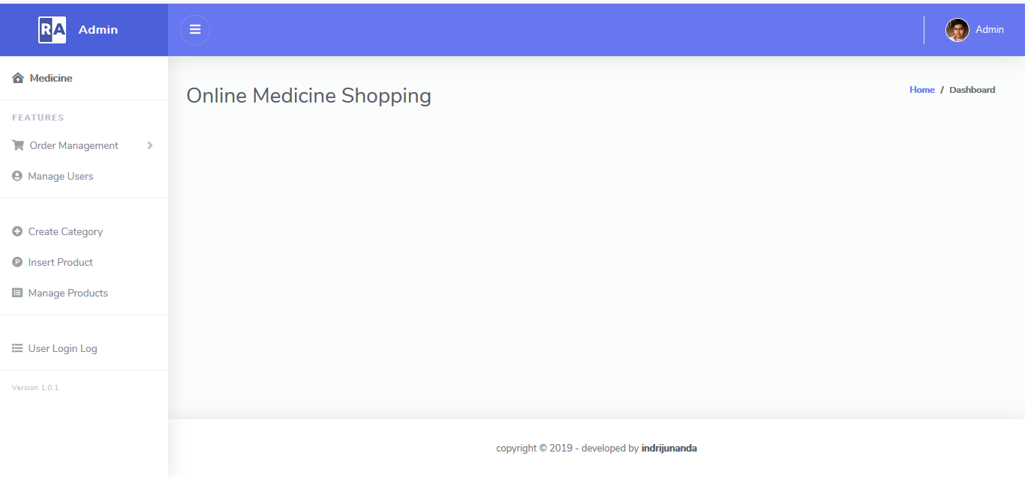

* Order Management: We click Order Management the dropdown will come in that Order Management can access Today Order, Pending Order, Delivered Order.
* Today Order: you can see today’s order details and update orders.

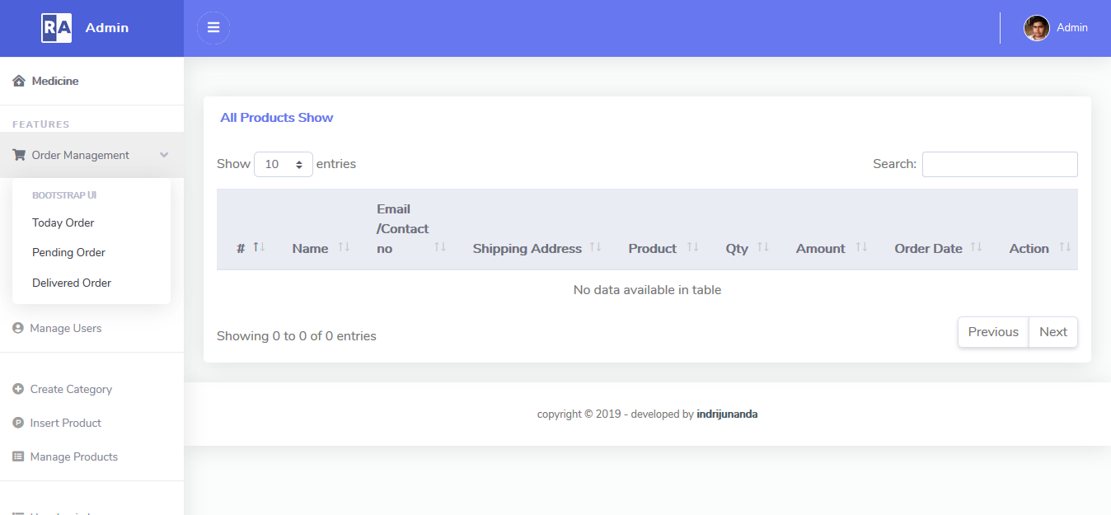

* Pending Order: you can see pending order details and update orders.

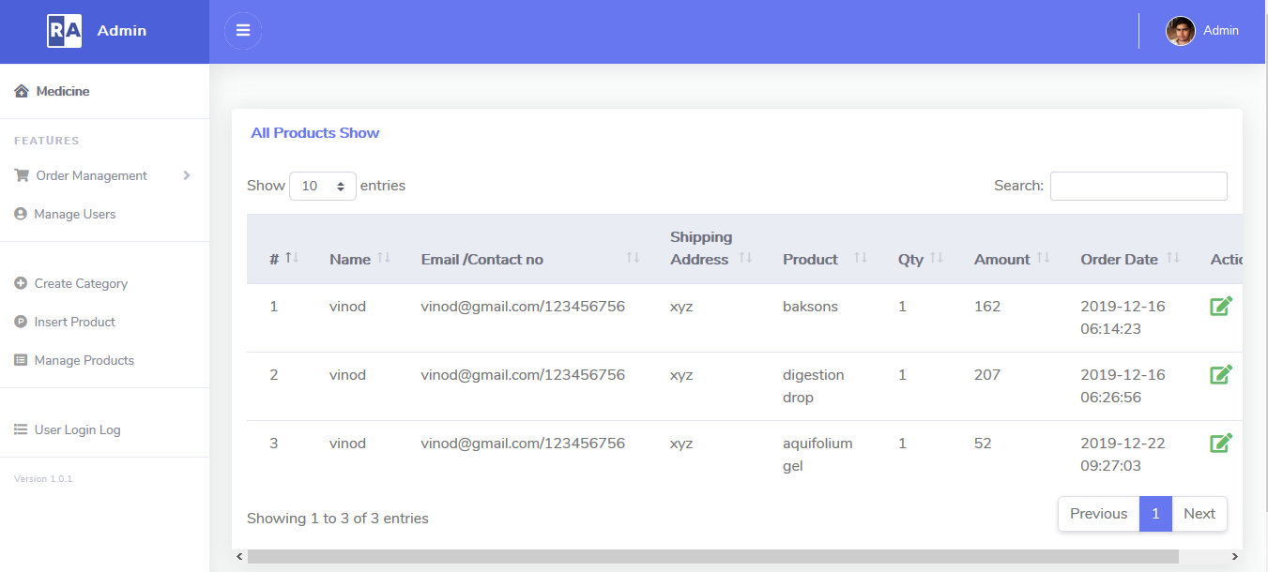

* Delivered Order: you can see delivered order details and update orders.

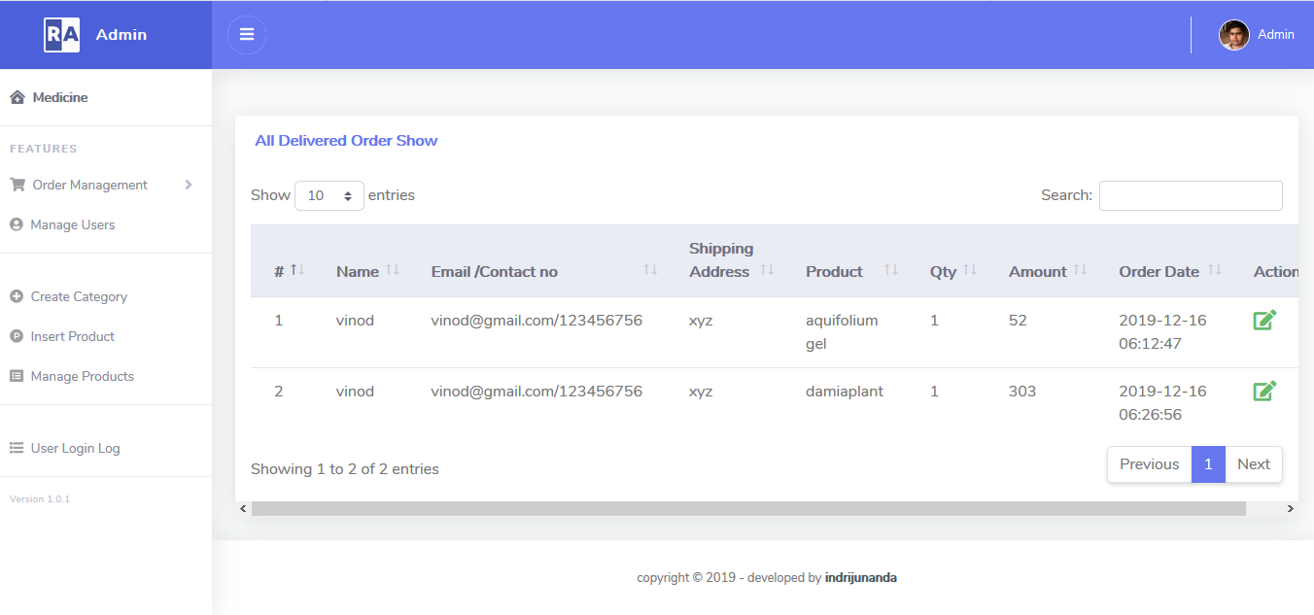

* Manage Users: you can see all user sign-up details.

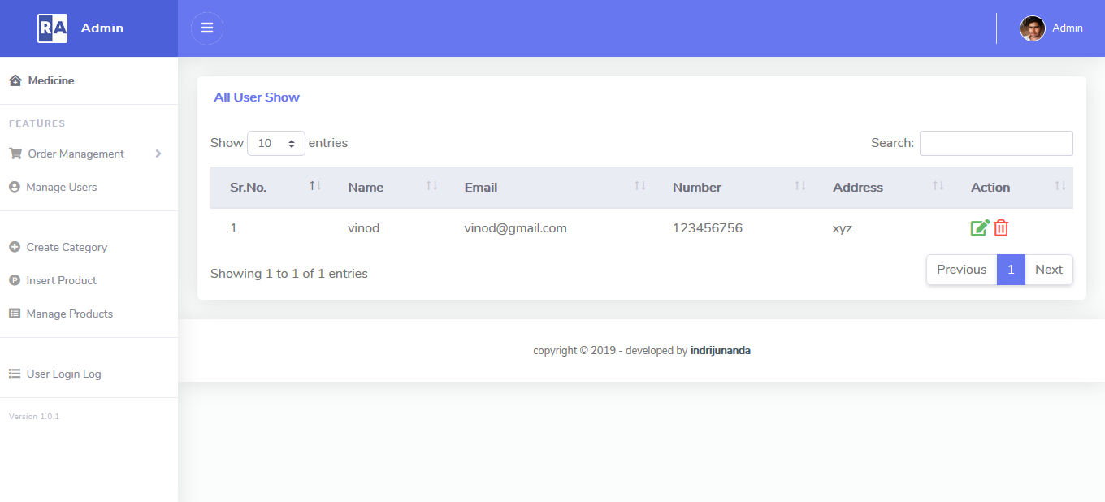

* Create Category: admin can add new category and also can update and delete.

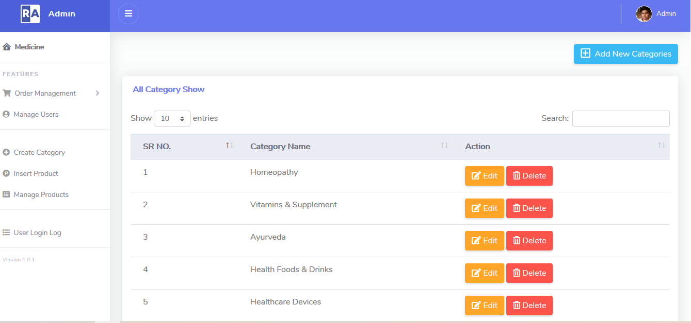

* Insert Product: admin can insert new product.

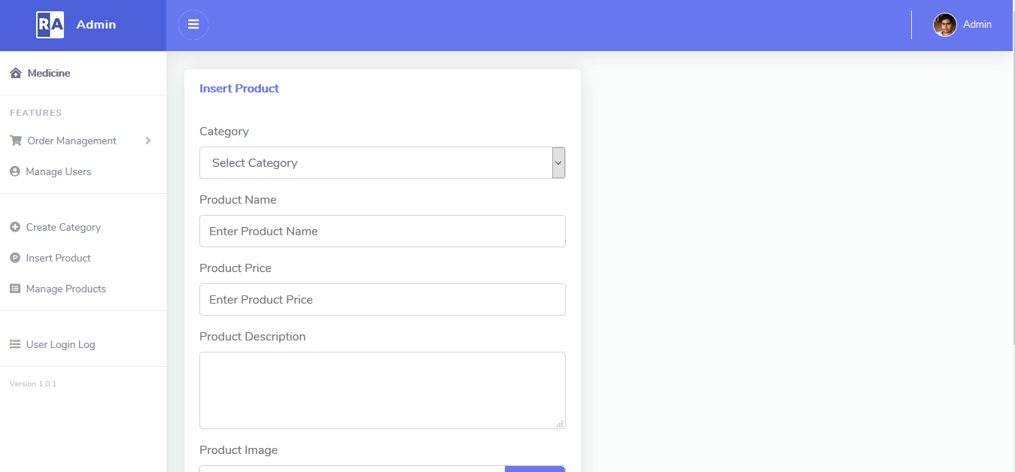

* Manage Product: admin can mange the product and also can edit and delete the product

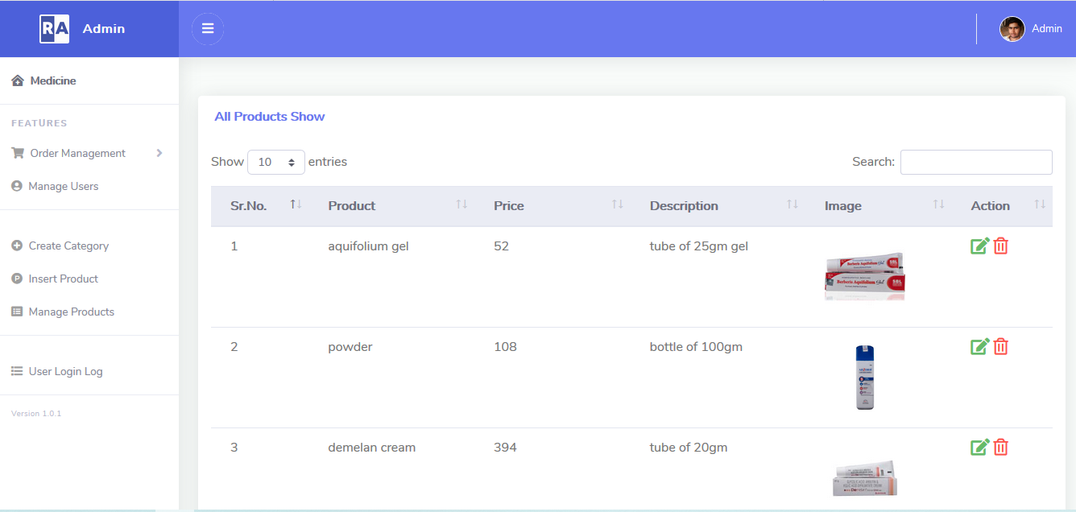

* User Login Log: admin also see when user login then login time, when logout then logout time,user IP and status.

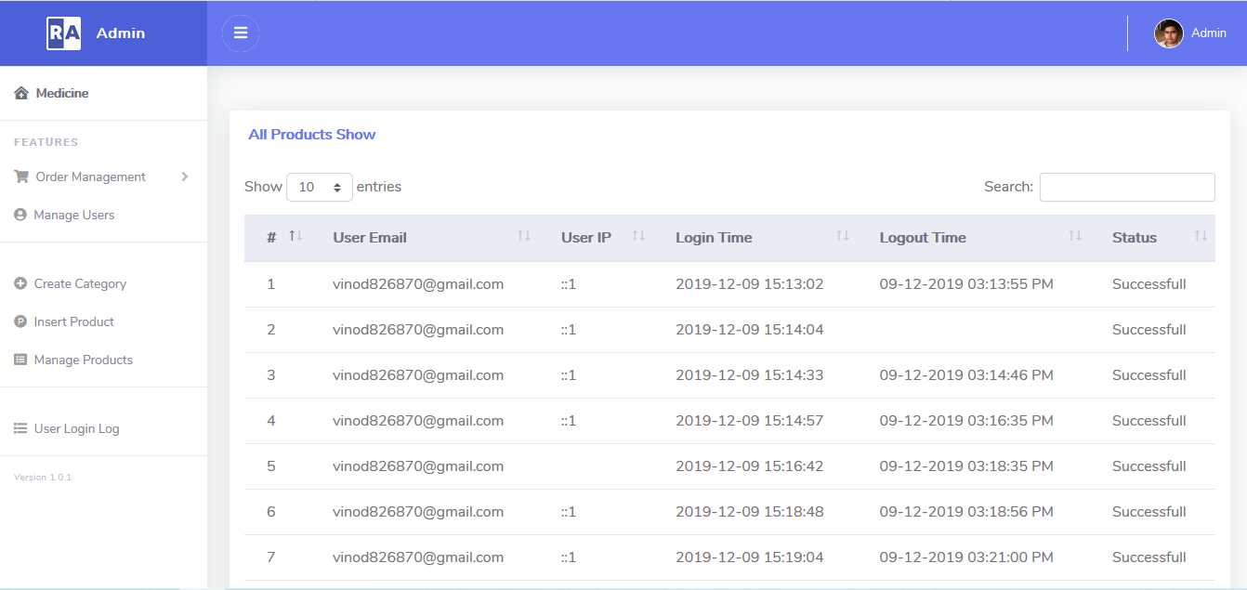

User

#### STEP 1:

Now run *index.php* file from localhost.

E.g. http://localhost/phptutorial/OMSW/index.php By visiting *login.php* you can see the below page.

* User log page: user can signup and login.

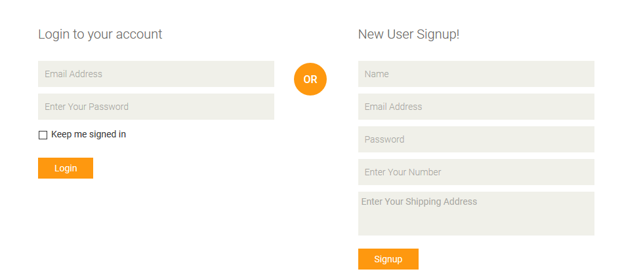

#### STEP 2:

User Login with Email : *vinod@gmail.com* | Password :*123.*

#### 

#### STEP 3:

#### After login you can see the user home page.

* Home: This is the user home page user can add the product in shopping card .

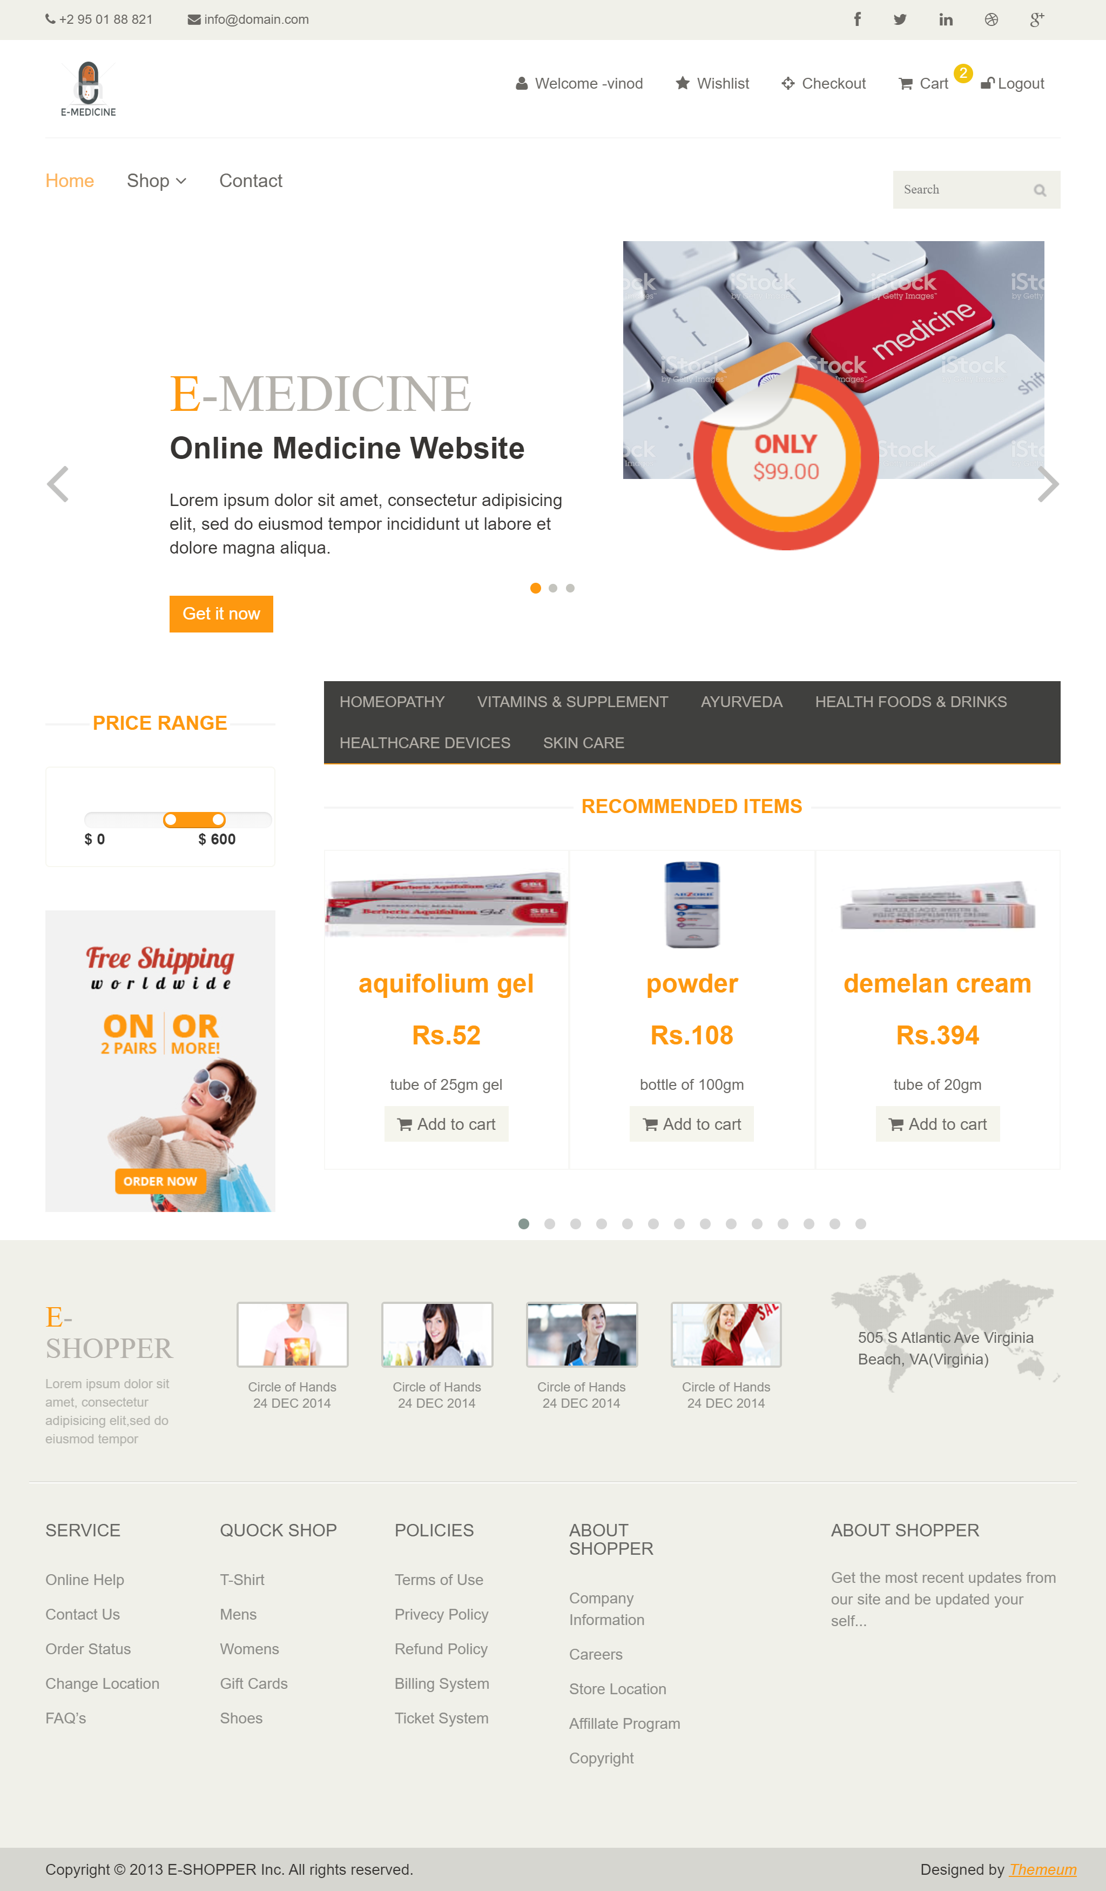

* Shop: We click Shop the dropdown will come in that Shop can access Product, Order Details, cart.
* Product: when user click product the product page arrange the product in category wise

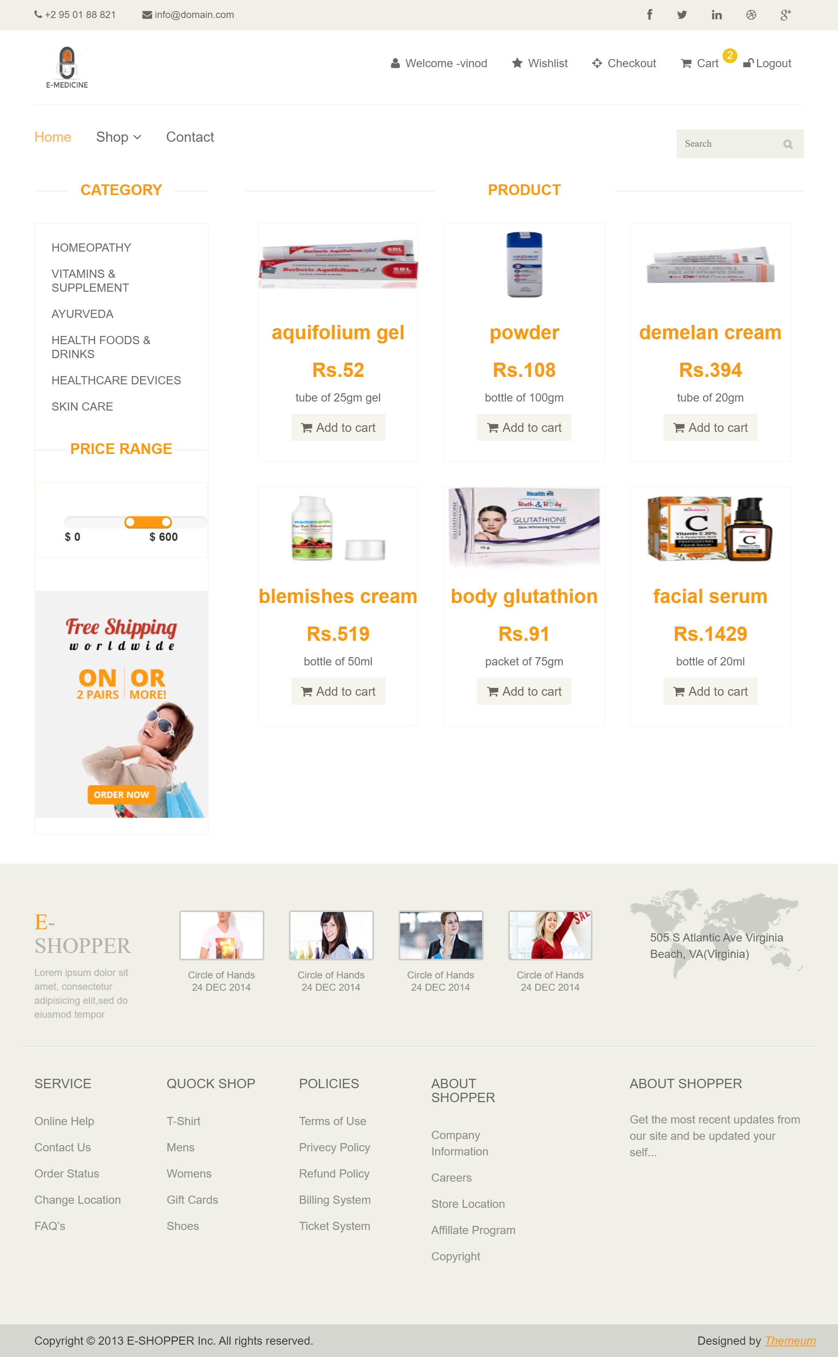

* Order Details: user can see the order and details of the order.

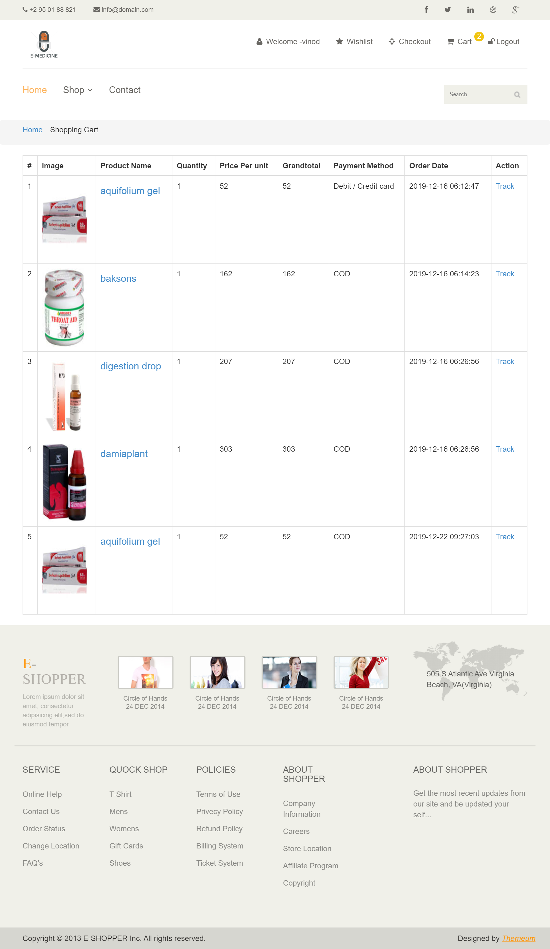

#### STEP 4:

#### After login you can see the Contact in Navbar.

* Contact: this is the contact from to contact us admin.

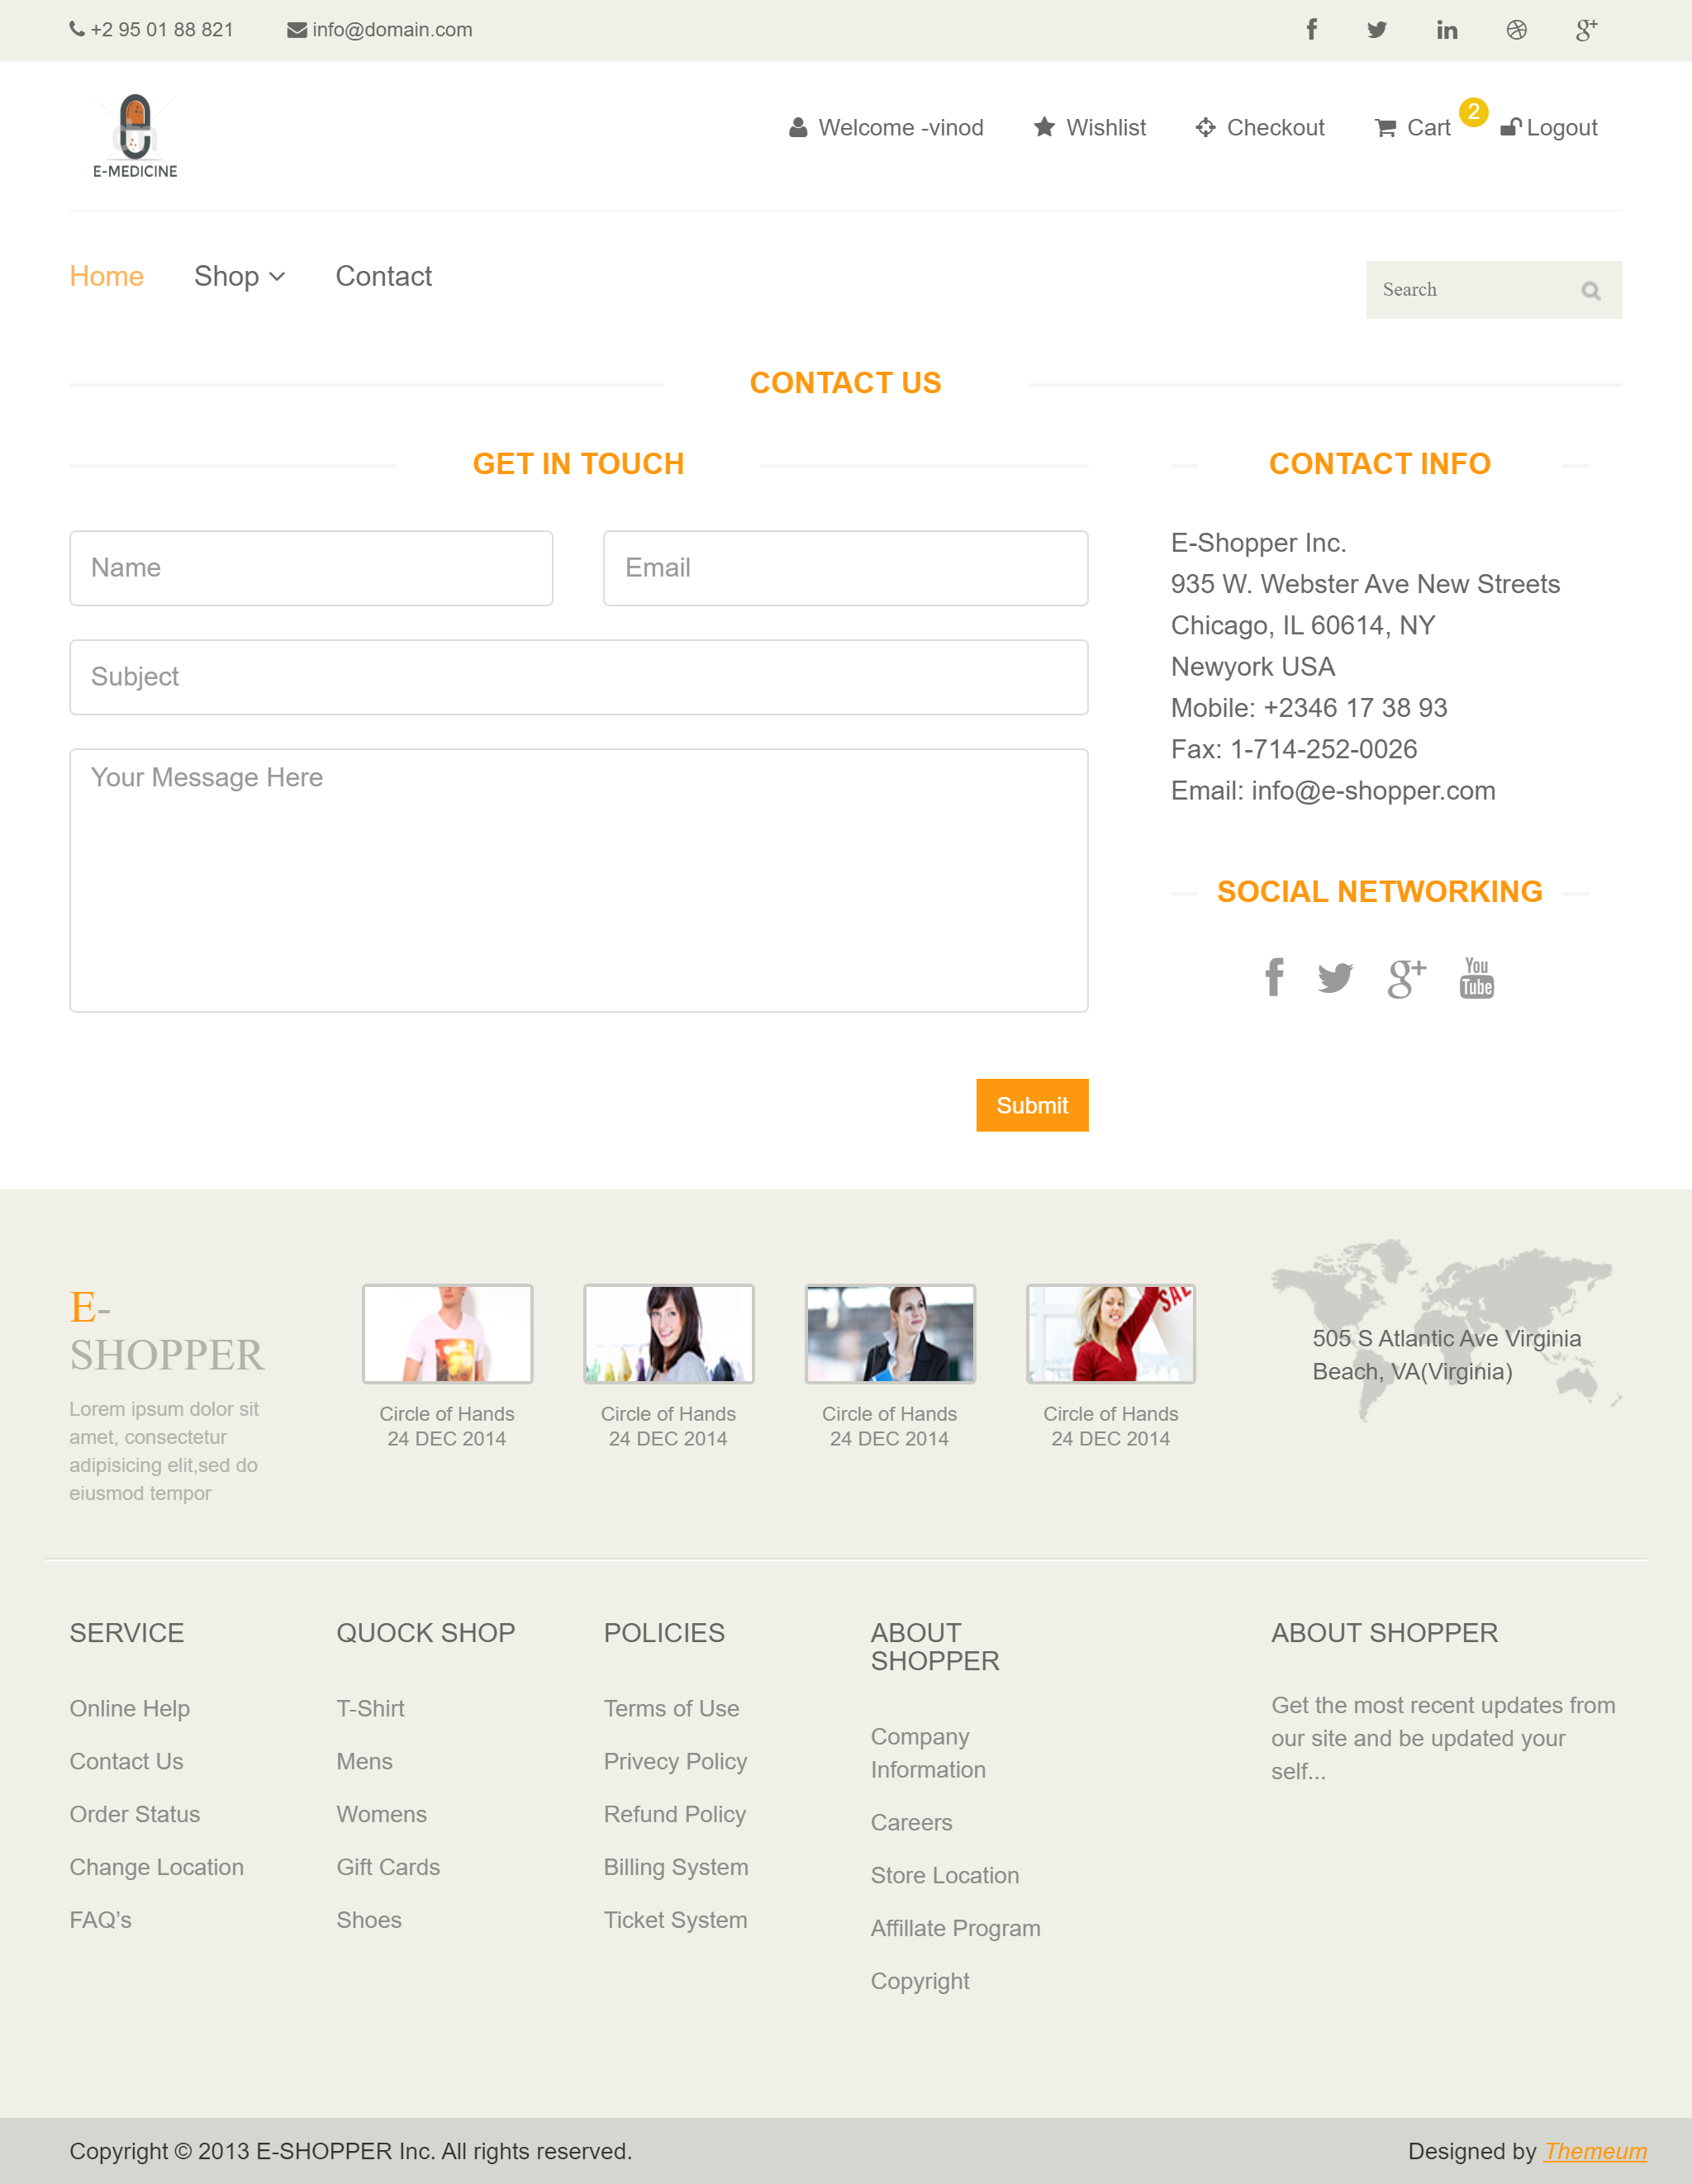

* cart: When user product add to cart then product add in cart list and user also can edit and remove to product in cart list.

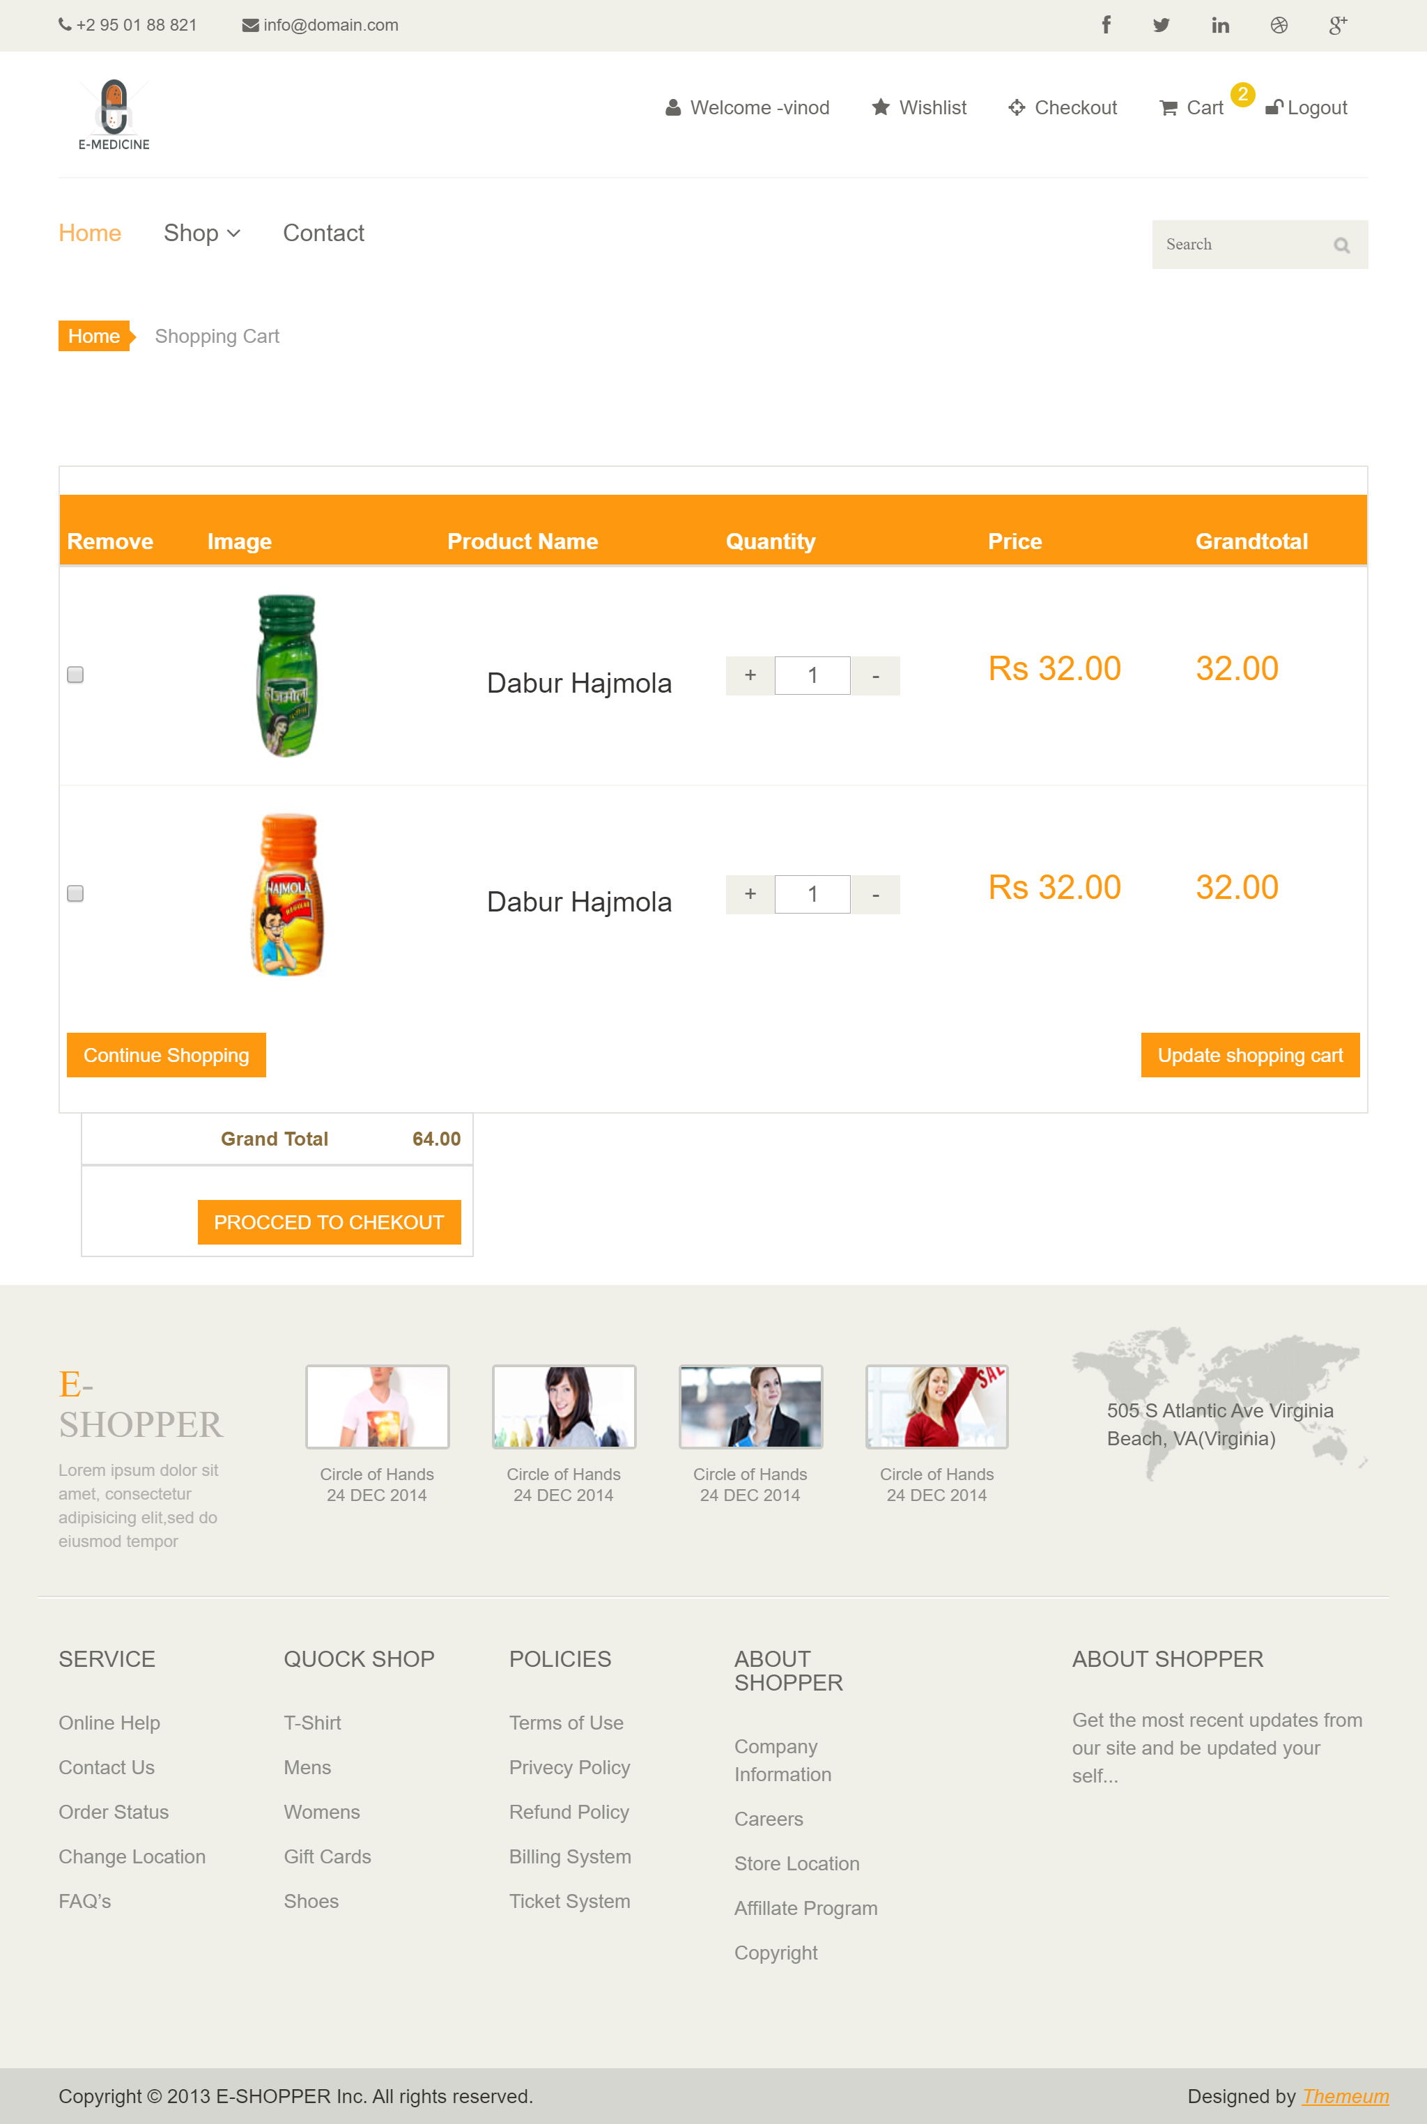

Procced to Checkout: When user click in cart proceed to checkout button then go to payment method page.

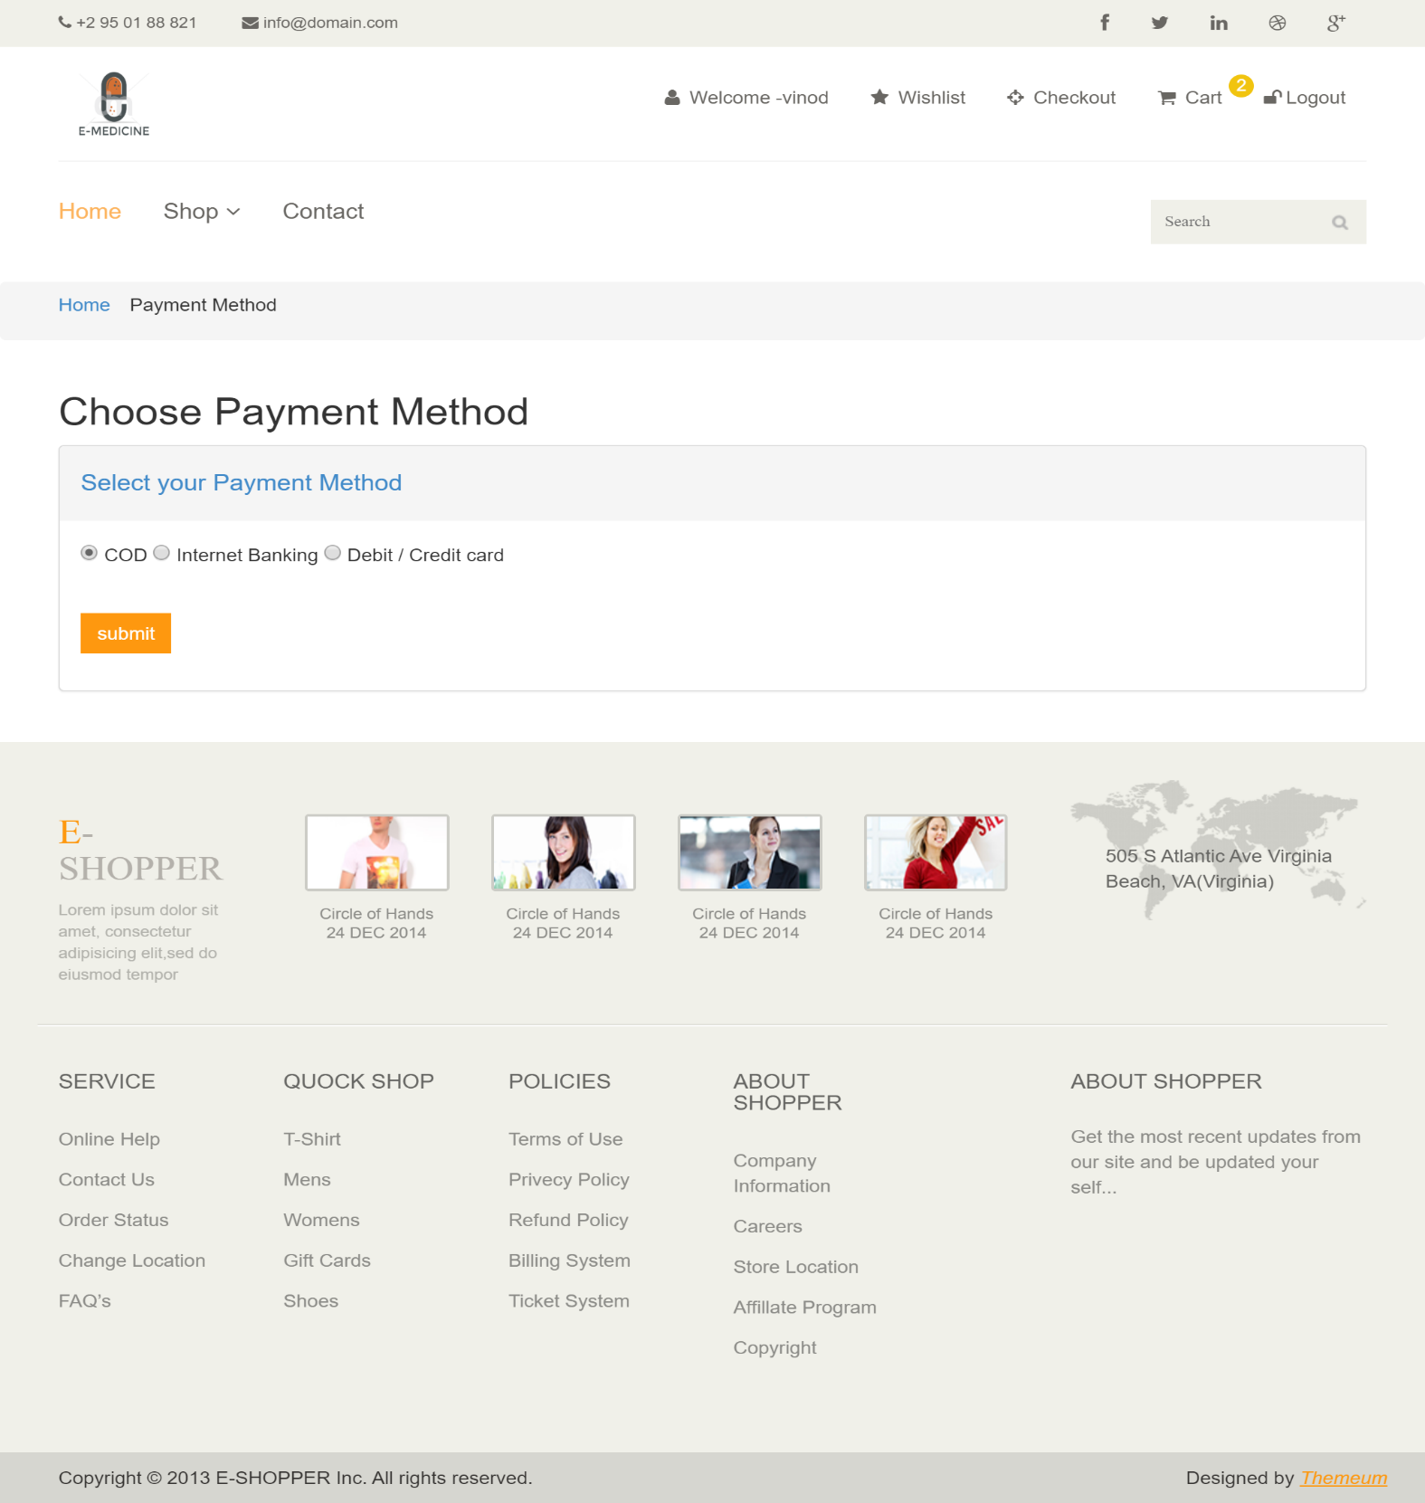

Submit: when user click submit button then go to the order-history page and check to the order details.

